Parth Babbar

Health saving account

**Introduction:**

Health Savings Accounts (HSAs) are tax-advantaged medical savings accounts available to U.S. taxpayers who participate in a High-Deductible Health Plan (HDHP). These accounts are intended to help individuals and families properly manage their healthcare spending. Contributions to an HSA are not subject to federal income tax at the time of deposit, which provides considerable tax advantages. HSAs provide a realistic financial instrument for covering healthcare bills while benefiting from tax-free growth and withdrawals for eligible medical expenses.

**Features:**

1. **Tax-Benefits:** Contributions to a Health Savings Account (HSA) are tax deductible, lowering your taxable income. Earnings in the HSA grow tax-free, and withdrawals for eligible medical costs are tax-free. This combination of features makes HSAs an effective tool for controlling healthcare expenses while also providing large tax savings.
2. **Contribution Limits:** For 2024, the Health Savings Account (HSA) contribution limits are $4,150 for self-only coverage and $8,300 for family coverage. Individuals 55 and older can make a $1,000 catch-up contribution. Contributions for a particular taxable year are accepted until the tax filing deadline, which is normally April 15 of the following year.
3. **Ownership:** Individuals own Health Savings Accounts (HSAs), not their employers, which gives them complete control over the account. This ownership assures portability, which means that the assets in the HSA stay with the individual regardless of job changes or retirement, allowing them to continue receiving benefits from the account regardless of their work situation.
4. **Investment Options:** HSAs provide a variety of investment alternatives, including stocks, bonds, mutual funds, and ETFs, with the possibility for growth through investment returns.  
   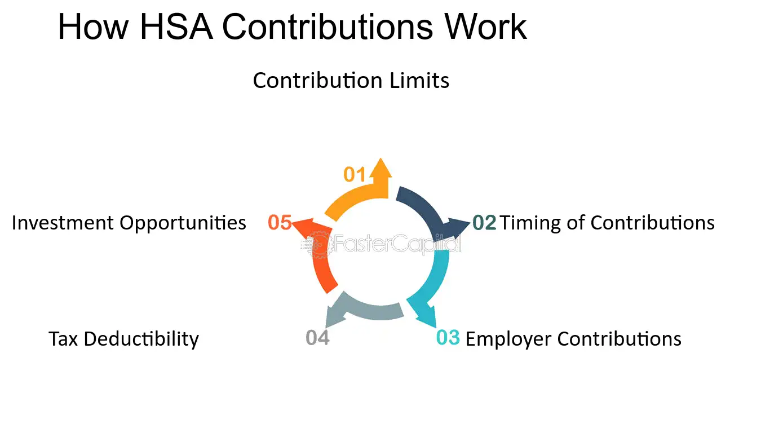

**Eligibility Requirements:**

To open a HSAs account the following requirements should be fulfilled:

1. An High-Deductible Health Plan(HDHP) has greater yearly deductibles and out-of-pocket maximums than a standard health plan. In 2024, the minimum deductible for an HDHP is $1,600 for individual coverage and $3,200 for family coverage.
2. You cannot be covered by another non-HDHP health plan.
3. You should not be enrolled in Medicare.
4. You cannot be claimed as a dependant on another person's tax return.

**Medical Expenses Covered:**

HSAs can cover a variety of medical expenditures, including:

1. Doctor visits and hospital services
2. Prescription medications
3. Dental and vision care
4. Long-term care services
5. Health insurance deductibles and copayments

**Withdrawals:**

1. **Qualified Withdrawals:** Withdrawals for qualifying medical costs are tax-free.
2. **Non-Qualified Withdrawals:** Non-qualified withdrawals are subject to income tax and a 20% penalty.

**Advantages & Disadvantages:**

**Advantages:**

1. **Triple Tax Benefit:** Contributions are tax deductible, gains grow tax-free, and withdrawals for qualifying medical costs are tax-free.
2. **Retirement Savings:** Unused money can be kept for retirement, and withdrawals after age 65 are taxed as ordinary income, with no penalty.
3. **Investment Options:** Many HSAs enable you to invest in stocks, bonds, and mutual funds, which can help your money grow.
4. **Flexibility:** Funds can be used to pay for a variety of approved medical bills, giving you more control over your healthcare spending.
5. **Portability:** Individuals own HSAs, which stay with them regardless of work situation, enabling continuing access to money.

**Disadvantages:**

1. **Eligibility Requirements:** Only individuals with high-deductible health plans are eligible to create an HSA.
2. **High Deductibles:** HDHPs have greater out-of-pocket payments before insurance coverage begins.
3. **Penalties for Non-Qualified Expenses:** Withdrawals made before the age of 65 are subject to a 20% penalty and income tax.
4. **Complexity:** Understanding and administering an HSA may be challenging, particularly in terms of investment alternatives and tax consequences.

**Statistics:**

1. According to Devenir's 26th semi-annual HSA survey, $116 billion in HSA assets were held in almost 36 million accounts at the midpoint of 2023, representing a 17% rise in assets and 6% in accounts year on year. A graph of a number of assets

   Description automatically generated with medium confidence
2. Invested Funds in Health Savings Accounts (HSAs) generally allocate roughly 25% to stocks, bonds, and mutual funds, providing account holders with the opportunity for growth through investment returns. While some people use their HSA funds to pay for urgent medical bills, many prefer to save for future healthcare costs, taking advantage of HSAs' flexibility to combine current spending requirements with long-term savings objectives. This dual strategy enables consumers to successfully manage their present healthcare demands while also budgeting for future medical bills.

**Conclusion:**

Health Savings Accounts (HSAs) offer both considerable tax savings and flexibility in managing healthcare expenses. HSAs are designed for individuals participating in High Deductible Health Plans (HDHPs) and allow for effective savings for future medical expenses. Individuals may manage acute healthcare needs while also creating a solid financial buffer for retirement by carefully using these funds. As the healthcare and insurance landscapes shift, HSAs are positioned to become even more important in personal financial planning, providing a customisable approach to satisfy a variety of healthcare and savings goals.